**Assignment 02 – WordPress CMS Website (Basic Pages)**

**Instructions for completing template:**Replace **[bracketed red text]** with the requested information or screen capture.  
Replace **bracketed red text with black text** and then remove the brackets.  
Do not include full screen shot images, or full screen shots that are reduced in size. Use a snippet tool to capture parts of the screen and insert those images into the template.  
Do not remove tags from this template. Please answer all questions.  
**Please do not alter the formatting or delete parts of this template.**  
Assignment questions are not as detailed as activity questions.   
The assignment is where you demonstrate understanding of the material.

**Part A - Student Information**

1. **Student Name: [SYED AFTAABUDDIN] [A01]**
2. **Student Contact Information: [Email:** [**syedaftab299@gmail.com**](mailto:syedaftab299@gmail.com) **| Phone# 773-796-0029] [A02]**
3. **What day and date did you start this assignment: [Friday 1/15/2021] [A03]**

**Go back to the instructions and begin work on Part B.**

**Part B - Create 1 Shared Web Host WordPress CMS Website**

(1) Shared Web Host WordPress CMS Site Information:

Shared Web Host Name: [**Namecheap**] [B01]  
Shared Web URL: [**www.namecheap.com**] [B02]  
Shared Web Host Site Admin Username: [**saftaabu**] [B03]   
Shared Web Host Site Admin Password: [**50297006@Sps**] [B04]  
Domain Name: [**syedaftab.tech**] [B05]

Website Admin Username: [**saftaabu**] [B06]  
Website Admin Password: [**T0og`Z@g&HkBe**] [B07]  
Database Name: [**wp667**] [B08]  
Table Prefix: [**wpel_**] [B09]  
WordPress CMS Frontend Website URL: [**http://syedaftab.tech/mod2assign2/**] [B10]

-OR-

(2) Pantheon – WordPress CMS Site Information:

**Assignment Website Site Name:** **[Site Name here] [B01]**

**WEBSITE Admin Username:** **[Admin Username here] [B02]**

**WEBSITE Admin Password:** **[Admin Password here] [B03]**

**Pantheon Frontend Website URL:** **[Frontend website URL here] [B04]**

**Go back to the instructions and begin work on Part C.  
  
Part C - Extend the WP Shared Web Host Site with Menus**

1. SCREEN CAPTURE of the **Media** Library Page **[Dashboard > Media > Library]** showing the images you added in Grid and List View  
    **[Grid: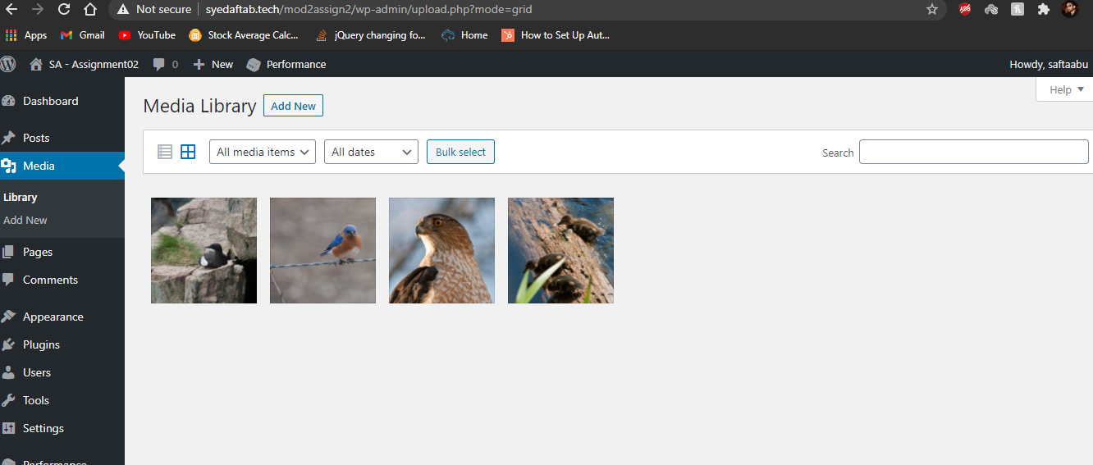] [C01.1]**

**[List: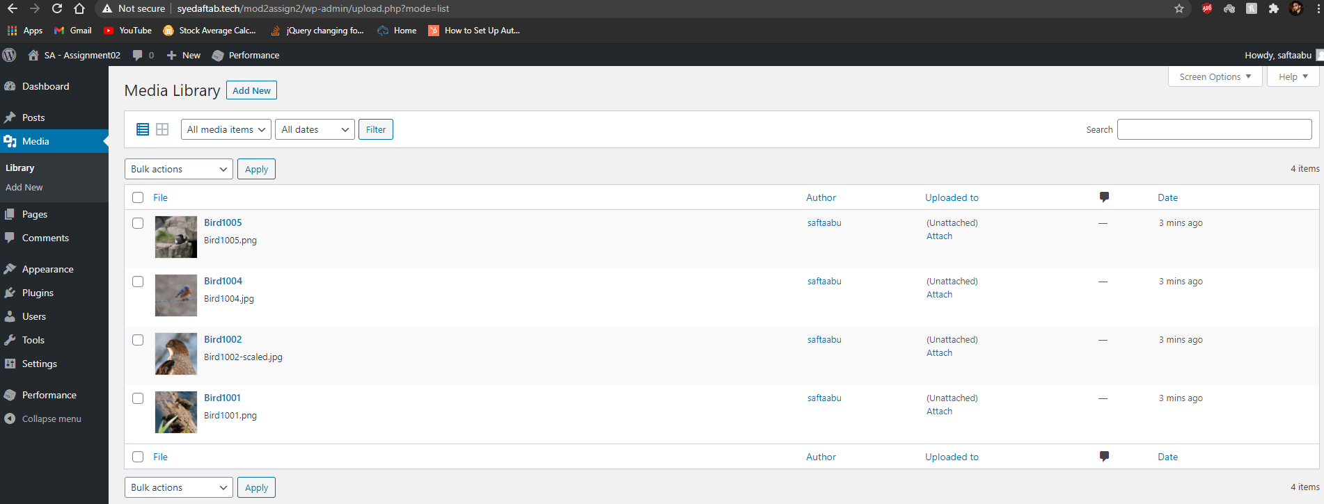] [C01.2]**

1. SCREEN CAPTURE of the **Menu** Page **[Dashboard > Appearance > Menu]** showing your Menu Name, and Menu Settings.  
   This may require multiple screen captures to show the check boxes at the bottom  
    **[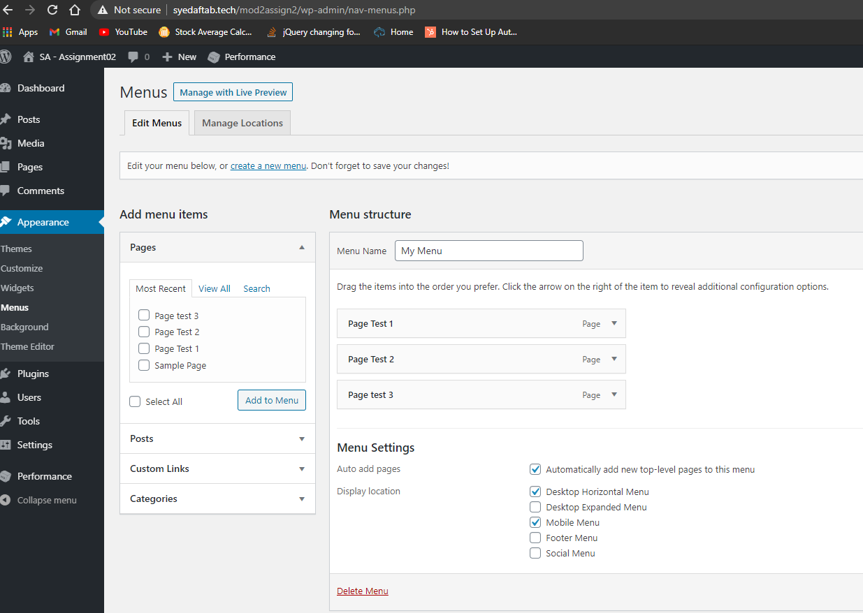] [C02]**
2. SCREEN CAPTURE of the Client Facing front end website, showing the test pages as menu items. Please make sure your screen capture shows the web browser address bar for full credit.   
   **[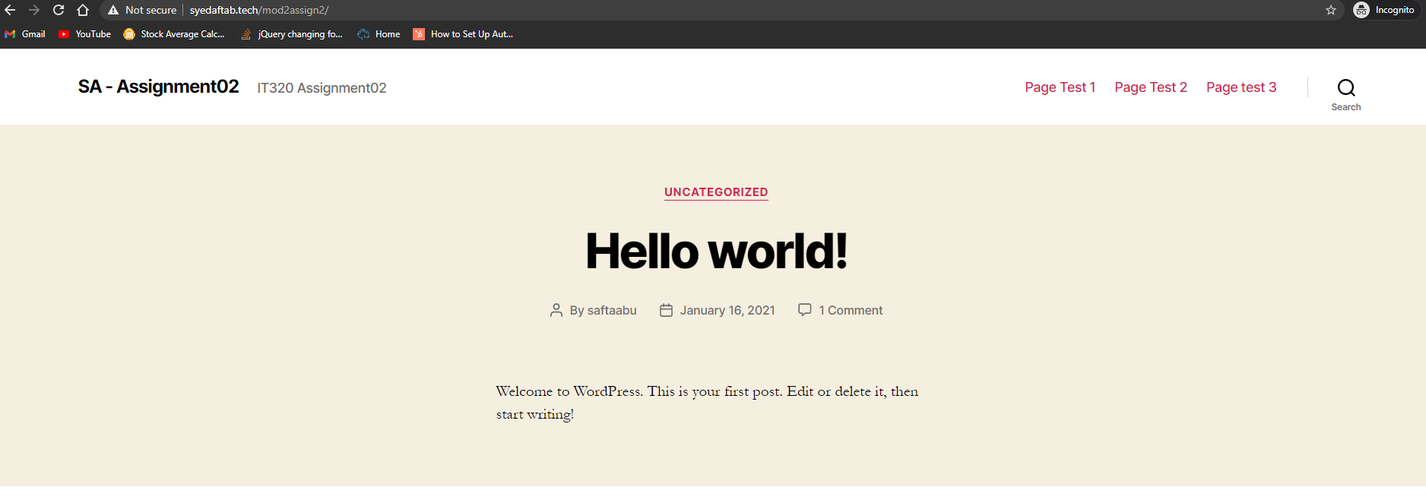] [C03]**

**Go back to the instructions and begin work on Part D.**

**Part D – Create a WordPress CMS Site on Codeanywhere: (REQUIRED)**

1. **D.1 Codeanywhere account and CMS site credentials:  
   NOTE:** Codeanywhere account credentials are required so the instructor can start the Connection container in order to test the WordPress site  
   Enter the following Codeanywhere web host account and WordPress site information **[D.1]**
   1. Codeanywhere account username (email): [**saftaabu**]
   2. Codeanywhere account password: [**50297006@Sps**]
   3. Site Title: [ **SA – Assignment 02 CA**]
   4. Website Admin Username: [ **saftaabu** ]
   5. Website Admin Password: [ **ppQJ5n1GAm&%q7MaiR**]
2. **Return to the instructions in part D.2 and continue working**

**D.2 - The screen captures for this part are from the Codeanywhere WordPress site you build and configure in Part E.**

1. **SCREEN CAPTURE of the Codeanywhere Info page. Please select and screen capture the entire web browser.  
   To display the Info page, right click on the left side connection, and select Info  
   [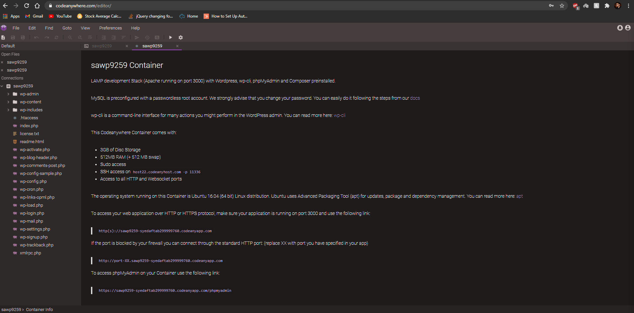] [D.2-01.1]**
2. **SCREEN CAPTURE of the Codeanywhere WordPress Backend Admin site,   
   selecting Dashboard > Home   
   Please make sure the “At a Glance” section is visible to verify the WordPress version and active theme.   
   [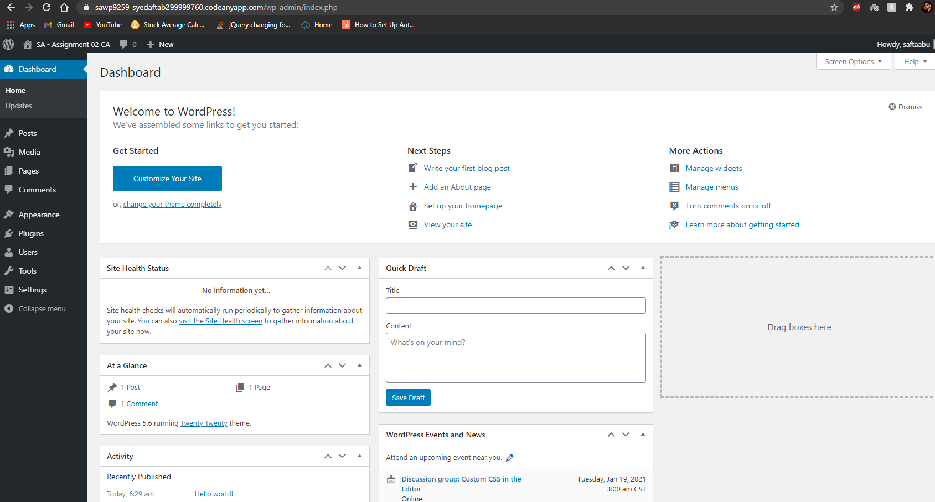] [D.2-01.2]**
3. SCREEN CAPTURE of the **Media** Library Page **[Dashboard > Media > Library]** showing the images you added in Grid and List View  
    **[Grid: 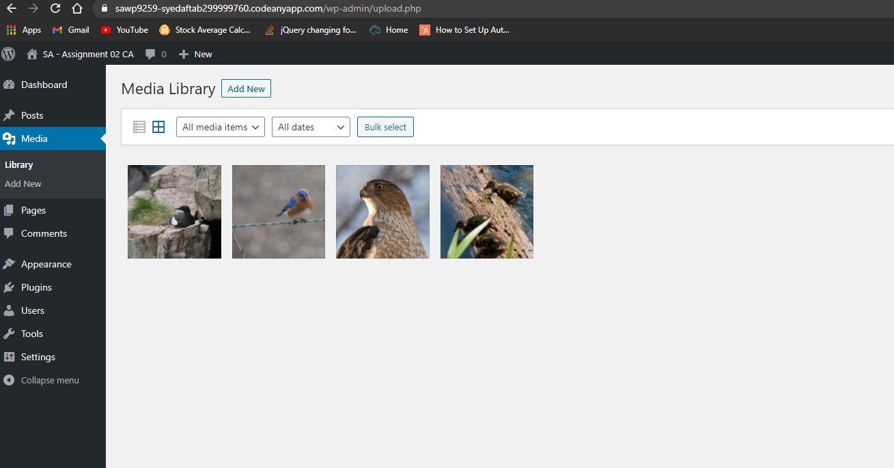] [D.2-02.1]**

**[List:** 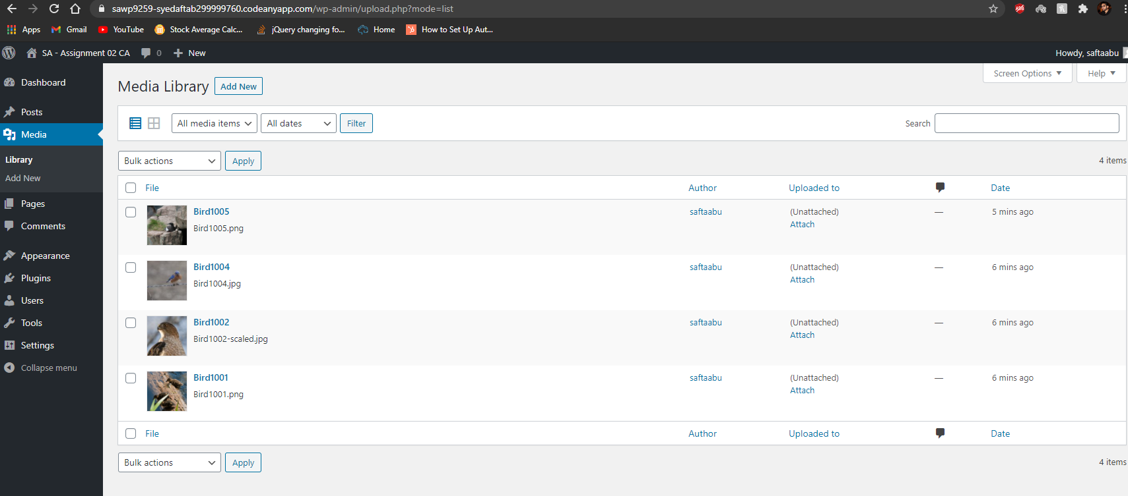**] [D.2-02.2]**

1. SCREEN CAPTURE of the **Menu** Page **[Dashboard > Appearance > Menu]** showing your Menu Name, and Menu Settings.  
   This may require multiple screen captures to show the check boxes at the bottom  
    **[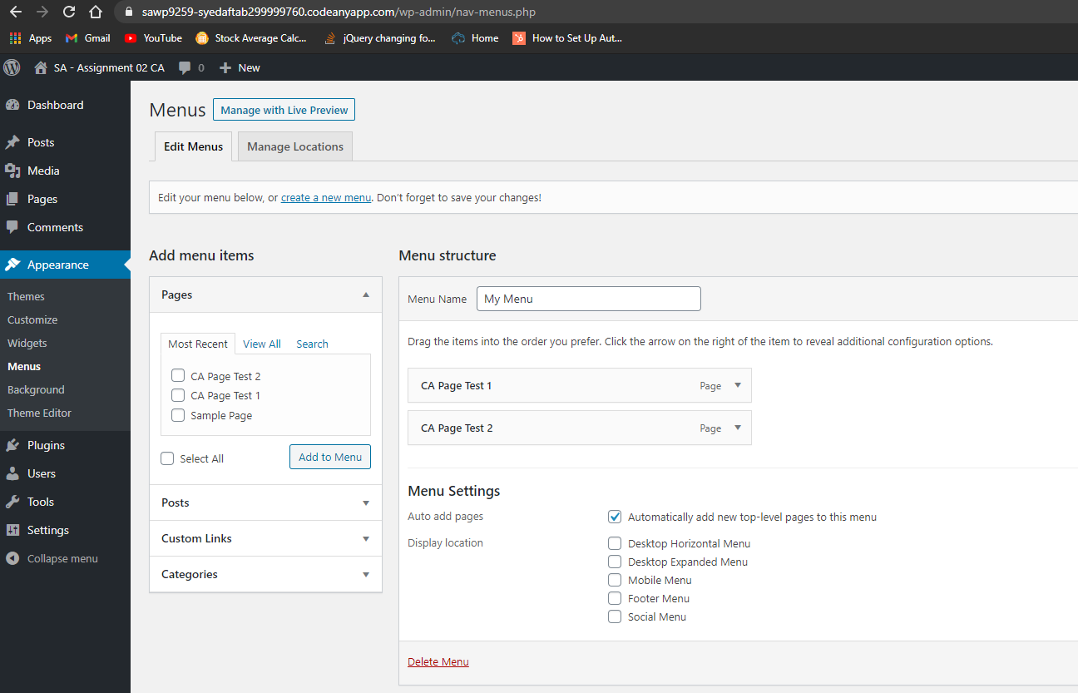] [D.2-03]**
2. SCREEN CAPTURE of the Client Facing front end website, showing the test pages as menu items. Please make sure your screen capture shows the web browser address bar for full credit.   
   **[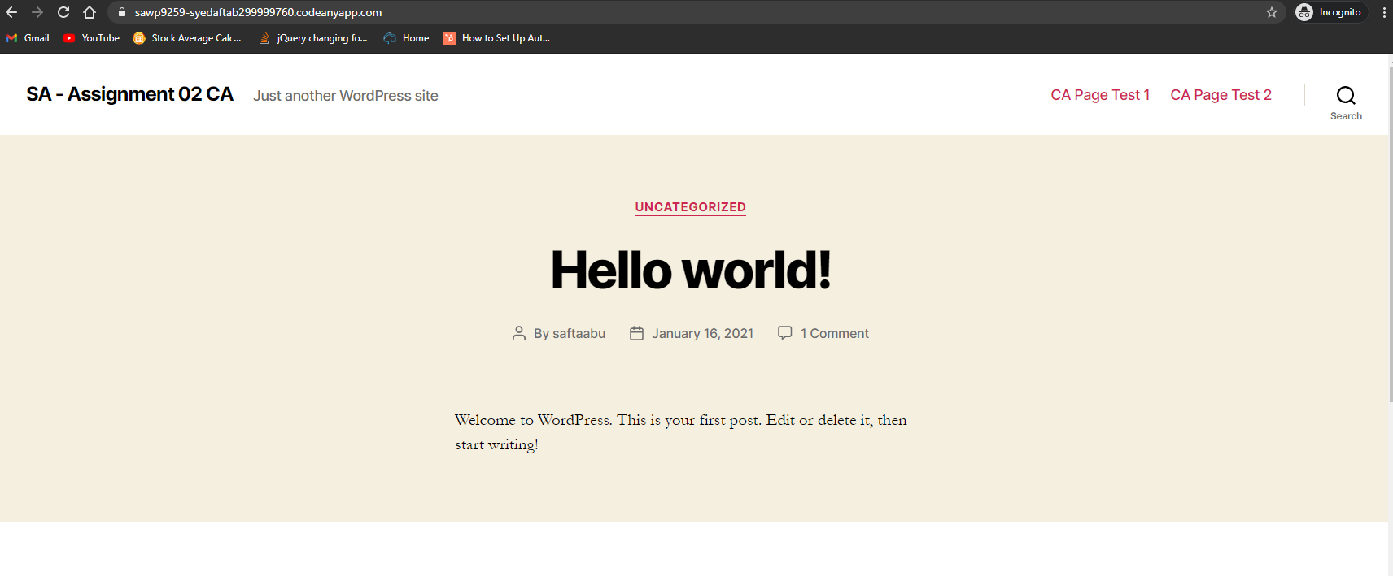] [D.2-04]**

**Go back to the instructions and begin work on Part E.**

**Part E - PHP Exercises:   
Testing PHP Programs using PHP Emulation Websites:**

* Online PHP test sites:
  + <http://phptester.net>
  + <http://www.writephponline.com/>
  + <http://sandbox.onlinephpfunctions.com/>
  + <https://wtools.io/php-sandbox>
* How you test your script depends on which test site you use.
* **Each PHP emulation test site works slightly different**.
* Please read the site instructions before testing your PHP code.

1. Demonstrate an understanding of how to code an echo statement by writing and executing a PHP program that echo the values of 3 variables named as you wish with values of an Integer, float (with a decimal point) and string. Execute your PHP code on a web PHP emulator (tester) and screen capture the code and output and paste it in the box below.

**Test your code using an online PHP test site and paste a screen shot of the tested code and results from the website emulator in the table cell below.**

|  |
| --- |
| Copy and paste the code block and record the results on the next row. A screen shot from the PHP test site will be the best way to not affect template format. Please try not to change the template numbering or format. **[E01]** |
|  |

1. Demonstrate an understanding of how to code PHP arithmetic operators by writing and executing a PHP program that echo the result of 5 lines of code, each one using one of 5 arithmetic operators, +, -, *, /, %. Use variables or constant values, named as you wish with values of integers, or floats (with a decimal point). Execute your PHP code on a web PHP emulator (tester) and screen capture the code and output and paste it in the box below.

**Test your code using an online PHP test site and paste a screen shot of the tested code and results from the website emulator in the table cell below.**

|  |
| --- |
| Copy and paste the code block and record the results on the next row. A screen shot from the PHP test site will be the best way to not affect template format. Please try not to change the template numbering or format. **[E02]** |
|  |

1. Demonstrate an understanding of how to code PHP concatenation operator by writing and executing a PHP program that echo the result of 5 lines of code, each one using the concatenation operator to join string variables or constant value. Variables named as you wish with string values. Execute your PHP code on a web PHP emulator (tester) and screen capture the code and output and paste it in the box below.

**Test your code using an online PHP test site and paste a screen shot of the tested code and results from the website emulator in the table cell below.**

|  |
| --- |
| Copy and paste the code block and record the results on the next row. A screen shot from the PHP test site will be the best way to not affect template format. Please try not to change the template numbering or format. **[E04]** |
|  |

1. Demonstrate an understanding of how to code PHP HTML TABLE output.  
   Variables names and values as follows. as you wish with string values. Execute your PHP code on a web PHP emulator (tester) and screen capture the code and output and paste it in the box below.
2. Creates 5 variables, with values “**A**”, “**Fine**”, “**Time**”, “**To Learn”, PHP**”.
3. Write PHP code that displays each variable in a single HTML TABLE.   
   Please build the table using embedded HTML Table tags and **concatenation operators.**  
   Please display each word above in a row, making the HTML TABLE a 1 column 5 ROW HTML TABLE.

|  |
| --- |
| A |
| Fine |
| Time |
| To Learn |
| PHP |

**Test your code using an online PHP test site and paste a screen shot of the tested code and results from the website emulator in the table cell below.**

|  |
| --- |
| Copy and paste the code block and record the results on the next row. A screen shot from the PHP test site will be the best way to not affect template format. Please try not to change the template numbering or format. **[E05]** |
|  |

1. Demonstrate an understanding of how to code PHP HTML TABLE output.  
   Variables names and values as follows. as you wish with string values. Execute your PHP code on a web PHP emulator (tester) and screen capture the code and output and paste it in the box below.
2. Creates 6 variables, with values “**A**”, “**Fine**”, “**Time**”, “**To” , “Learn”, PHP**”.
3. Write PHP code that displays each variable in a single HTML TABLE.   
   Please display each word above in a row, making the HTML TABLE a 2 column 3 ROW HTML TABLE.  
   Please build the table using embedded HTML Table tags and **concatenation operators.**

|  |  |
| --- | --- |
| A | Fine |
| Time | To |
| Learn | PHP |

**Test your code using an online PHP test site and paste a screen shot of the tested code and results from the website emulator in the table cell below.**

|  |
| --- |
| Copy and paste the code block and record the results on the next row. A screen shot from the PHP test site will be the best way to not affect template format. Please try not to change the template numbering or format. **[E06]** |
|  |

**Part F – Questions:**

1. List and describe in a few sentences 3 CMS core concepts covered on Modules 01 and 02?

|  |
| --- |
| 1. **CMS front-end and back-end** – we learned what make a software system a CMS. CMS websites are composed of 2 websites which is front-end (CDA) and backend (CMA). Front-end is the website everyone on the web sees and back-end is where users with administrator logins accounts can manage the website by adding, modifying, and deleting content. 2. **WordPress CMS Sites** – We learned how to create WordPress CMS Sites on a Shared Web Host cPanel accounts (Namecheap) and learned how to create WordPress Websites on Codeanywhere. 3. **Best Practices** – We covered the best practices technique. CMS best practices are important to follow when extending a CMS site. For example, when adding plugins, you must use best practices technique to choose the best plugin for your website. |

1. Based on the reading material and tutorial work, what does it mean to extend a CMS?

|  |
| --- |
| Extending a CMS means to add additional functionality such as adding plugins, themes, menus, images, adding users and setting user role privileges. |

1. Based on reading material and tutorial work, List and describe 3 best practices to follow when considering installing a plugin to extend a WordPress CMS?

|  |
| --- |
| **Compatibility** – You should determine if the plugin is compatible with your WordPress site version.  **Maintained** – It’s often updated and actively maintained.  **Star Rating** – You should check is the plugin has large number of installations and has good reviews. |

1. Based on the tutorial work, list and describe the steps on the WordPress admin dashboard to create and test a main menu that auto adds pages to itself in WordPress?

|  |
| --- |
| To create a new main menu, you select Appearance and then Menus. Enter a menu name where it asks you to enter and then press the “create menu button”. After creating the menu, check all the check boxes you’d like and then press “save menu” button. Next, to test the menu, add a page by creating a page and then checking that it was added to the main menu. To create a page, go to admin dashboard > pages > Add New. Enter a page title and then add some text into the body. Click the publish button and then check the front-end facing website. The new page should appear on a menu. Select the page link and the new page should open. That’s how you test menu/page you created in WordPress. |

1. What are 3 differences between WordPress.com and WordPress.org?

|  |
| --- |
| * **Full control** – WordPress.org has full control but WordPress.com does not. * **Hosting Storage** – WordPress.org has unlimited hosting storage but WordPress.com has limited. * **Membership Sites** – You can create membership sites in WordPress.org but you cannot in WordPress.com |

**Part G – Wrap up:**

1. **Did you have any problem or issues completing this assignment?  
   This is not an optional question.   
   [NO] [G01]  
     
   If you answered yes to this question, please elaborate and be specific.  
   If you had trouble with a specific question, please identify it by number and explain what you did not understand or had problems with.  
   I can only improve this assignment with your help.**

**[List problems here] [G02] *Only if you answered yes to G01**

Submit this completed template to the correct D2L assignment dropbox.If you prefer not to navigate by hand to the D2L dropbox, take advantage of the dropbox link in the D2L this module’s section. This link will take you to the correct assignment dropbox location.